**Mobile Innovations for Global Challenges**

**jQuery Mobile**

**Part 1 – jQuery Mobile questions**

Read the lecture notes on jQuery Mobile.

**Question 1:** What is the difference between mobile native and mobile web development?

Answer :- Mobile native is basically those applications which are developed specifically for the mobile platform or device. They are developed in a specific SDK , suitable for that particular platform. App-store approval needed. Will run on a specific device type. Access to all hardware API’s (Eg – Camera’s , Sensors , Touch-ID etc.).

Mobile web development are the web applications that are built to use in various mobile devices. No app-store approval needed. Will run on all mobile platforms.Access is through the device’s web browser so no downloading or installing is needed.

**Question 2:** Provide an example of an app from Google Play developed with mobile web technology.

Answer :- Facebook , Instagram , Twitter , Youtube.

**Question 3:** Provide an example of an app from Google Play developed with native technology.

Answer :- Hangouts , Google Play.

**Question 4:** Provide 4 names of mobile web browsers.

Anwer :- Safari , Mozilla Firefox , Opera Mini , Google Chrome.

**Question 5:** Install Opera Mobile Emulator <http://www.opera.com/developer/mobile-emulator> and access <http://seneweb.com> from it. What do you notice? Explain. Provide at least one screenshot.

Please provide this document with your answers.

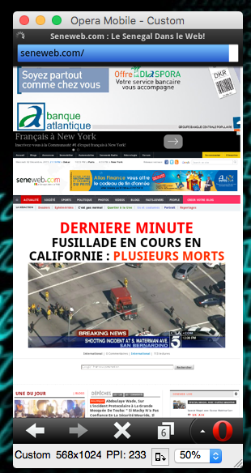

The page is presented really well for a mobile device , but there is a lot of information in a single page , which makes the user to scroll down a lot . User has to even zoom in and zoom out often to see the infromation properly. All Kinds of news from sports to politics is displayed . We have option to download an particular image if we want . We cannot watch videos (Unable to play).

**Part 2 – Develop a jQuery Mobile web site**

Create a mobile web site with jQuery Mobile about AppDock based on the design provided here:

Each team will have a specific app to build. The theme will be based on your team. It will be determined shortly.

Draw the design of the mobile web site and provide us with an image of the design.

Upload the files on webpage.pace.edu and provide us with the url to access it online.

The code should be available in GitHub.

Provide the URL to access your jQuery Mobile web site (webpage.pace.edu or other).

**Part 3 – Package the mobile web site into an app**

You will use Intel XDK to do so.

[https://software.intel.com/en-us/intel-xdk](https://software.intel.com/en-us/intel-xdk" \t "_blank)

The Android app (apk file) should be available in GitHub.

Provide the URL to access the apk file in GitHub.